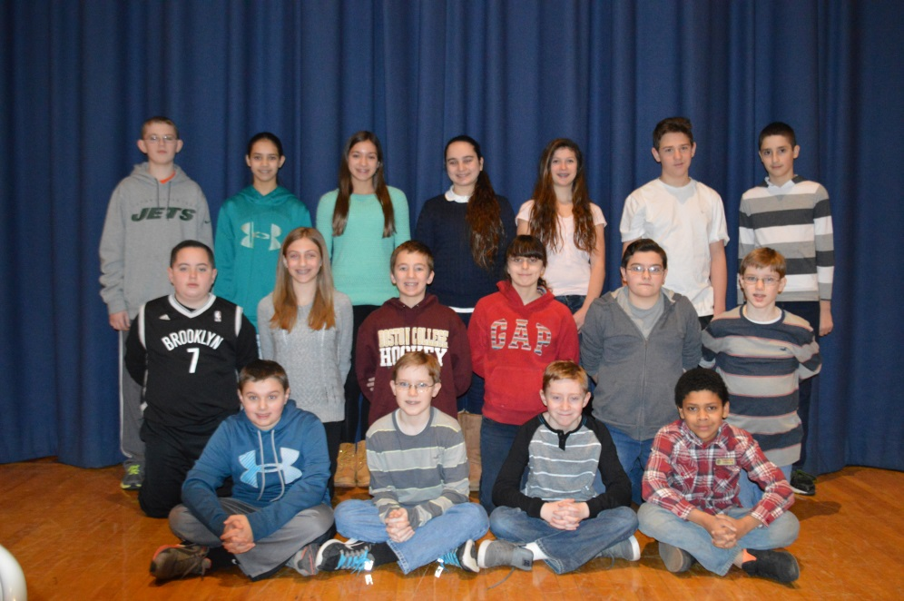
The Music Department at NMS is proud to announce twenty of our young musicians have achieved All-County honors. All County band: Brendan Dervan, Christopher Dervan, Leah Golbert, Caitlin Leodis, Richie McGuigan, and Sujata Tank. All County Chorus: Jacqueline Balestrieri, Alanna Beerman, Brandon Belcher, Isabella Costa, Shane D’amico, Ryan Dunston, Antonio Fondacaro, David Longley, Aidan Maggor, and Lauren Tirado. All County Orchestra: Christian Augugliaro, Emma Khan, James McDermott, and Jessica Nemeth.
The students will rehearse with musicians from other schools from Suffolk County and perform a concert.
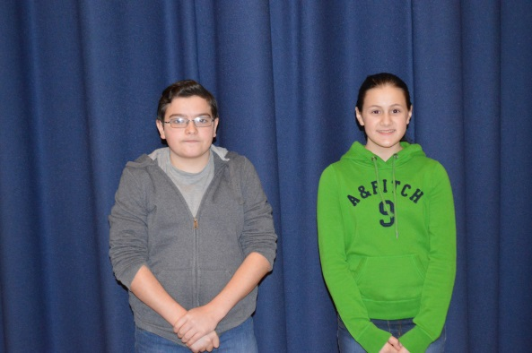
In addition to our All County honors, James McDermott and Irene Flanagan (left) have been chosen to participate in LISFA (Long Island String Festival). They too will have the opportunity to perform with other fine musicians from Long Island.
Congratulations to all of our talented young musicians.

